YAML EDITOR IN AZURE DEVOPS

- What is YAML?
YAML (YAML Ain’t Markup Language) is a human-readable data format used for configuration files. It is designed to be simple and clear, making it easier to define settings in text format. YAML is commonly used in cloud, DevOps, Kubernetes, CI/CD pipelines, and configuration management tools.YAML uses Indentation and colon to structure the data serialization language.

- Purpose of YAML in Azure DevOps
In Azure DevOps, YAML is used to define CI/CD pipelines as code. This concept is called "Pipeline as Code," which makes the development and deployment process more automated, version-controlled, and reproducible.
Instead of creating pipelines using a graphical interface, you can write all your build and deployment instructions in a .yml file. This file is stored in your repository, which means:
- Your pipeline evolves with your code.
- It supports collaboration.
- You can reuse and audit your pipeline easily.

- What is the YAML Editor?
The YAML Editor in Azure DevOps is a built-in code editor that helps you write and manage your YAML pipeline definitions. It provides features like syntax highlighting, IntelliSense (auto-suggestions), and validation.
You can access the YAML editor by:
- Going to Azure DevOps > Pipelines > New Pipeline.
- Connecting your repository.
- Choosing to configure using YAML.

- Key Features of YAML Editor in Azure DevOps:

- Inline editing: Write your YAML pipeline directly in the browser.
- IntelliSense: Auto-complete and suggestions for pipeline syntax.
- Validation: Detects errors and invalid syntax before saving.
- Template Support: Allows code reuse using template files.
- Conditional logic: Use if/else to run steps based on conditions.
- Integration with Secrets: Use secure variables from Azure Key Vault or pipeline variables.

- Advantages of YAML Pipelines

- Code as Pipeline: Pipeline logic lives in your code repository.
- Version Control: Any change is tracked via Git commits.
- Reusability: Define reusable templates for steps or jobs.
- Flexibility: Add custom scripts, conditions, and environment configurations.
- DevOps Friendly: Aligns with Infrastructure as Code (IaC) practices.

- Types in YAML:

YAML supports several data types that help organize and represent data clearly. Here’s an explanation of each type:

- Scalars:

Scalars are the simplest data types in YAML. They represent single values such as strings, integers, booleans, Null,etc.It doesn’t contain Indentation.

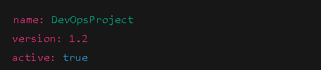

- name is a string
- version is a float
- active is a boolean
- You can also use quotes (" " or ' ') for strings, especially when they contain special characters.

- List:

Lists are a group of related items. YAML lists use a dash - followed by a space for each item.Combination of scalars and list.

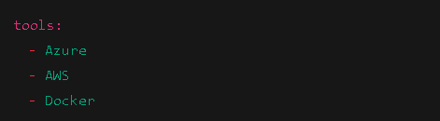

- Mapping:

Mapping are collections of key-value pairs. This is similar to JSON objects.It can be nested each other.

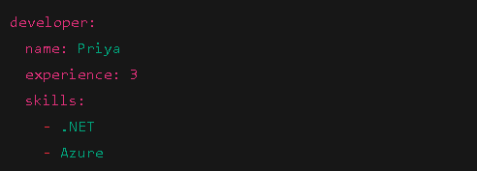

In this example:
- developer is the main key.
- Under it, we have name, experience, and a skills list.
This shows how YAML can represent nested structures.

- Multiline Scalar:

In YAML, a multiline scalar is a block of text (like a paragraph or string spanning multiple lines) defined in a way that YAML can parse and preserve the structure or content correctly.

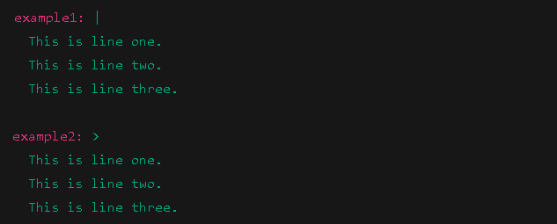

- YAML Indentation:

- Indentation means adding spaces at the start of a line.
- It shows hierarchy and parent-child relationships between keys and values.
- YAML uses indentation instead of braces or brackets like JSON.
- Indentation level is critical — wrong indentation causes errors.

Rules of YAML Indentation
- Use spaces only.
- Never use tabs (most errors happen because of tabs).
- Use 2 spaces per level (this is the most common and recommended).
- All child elements must be indented more than their parent.
- Items at the same level must have the same indentation.

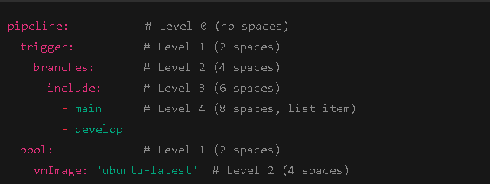

- YAML Pipeline Hierarchy:

1. Pipeline Root
- The whole YAML file represents a pipeline.
- Top-level keys define main sections like trigger, pool, variables, stages, etc.
- Each top-level key starts at no indentation (0 spaces).

2. Trigger
- Defines when the pipeline should start.
- Typically includes branches or paths to watch for changes.

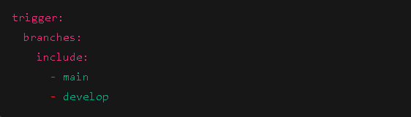

Pool
- Defines the agent environment for running jobs.
- Usually specifies the VM image.
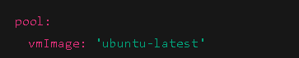

Stages
- Top-level organizational units that group jobs.
- Stages run sequentially by default but can be configured to run in parallel.
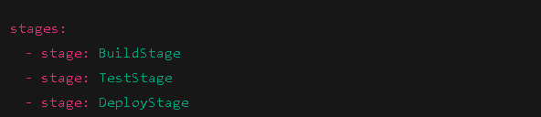

Jobs
- Jobs are inside stages.
- Each job runs on one agent and contains multiple steps.
- Jobs can run sequentially or in parallel inside a stage.
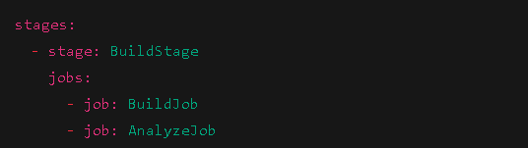

Steps
- Steps are the smallest units inside a job.
- Steps execute commands, scripts, or predefined tasks.
- Steps run one after another in the job.
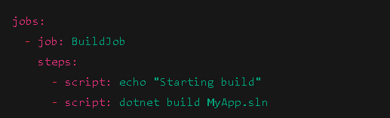

Script
- A script is a step that runs shell or PowerShell commands.
- Can be single line or multiline.
Single line script->
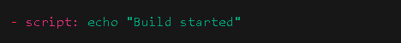
Multiline script->
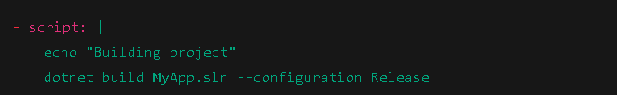

Full Example Putting It All Together:

trigger:
branches:
include:
- main

pool:
vmImage: 'ubuntu-latest'

variables:
buildConfig: 'Release'

stages:
- stage: BuildStage
jobs:
- job: BuildJob
steps:
- script: echo "Starting build"
- script: |
echo "Building project"
dotnet build MyApp.sln --configuration $(buildConfig)

- stage: TestStage
jobs:
- job: TestJob
steps:
- script: dotnet test MyApp.Tests/MyApp.Tests.csproj

Step-by-Step: Create YAML Pipeline in Azure DevOps For .NET application.

Step 1: Go to Azure DevOps
- Open https://dev.azure.com
- Sign in with your Microsoft account
- Select your organization and then the project

Step 2: Go to Your Repository.

- Create a new file with .yaml extension

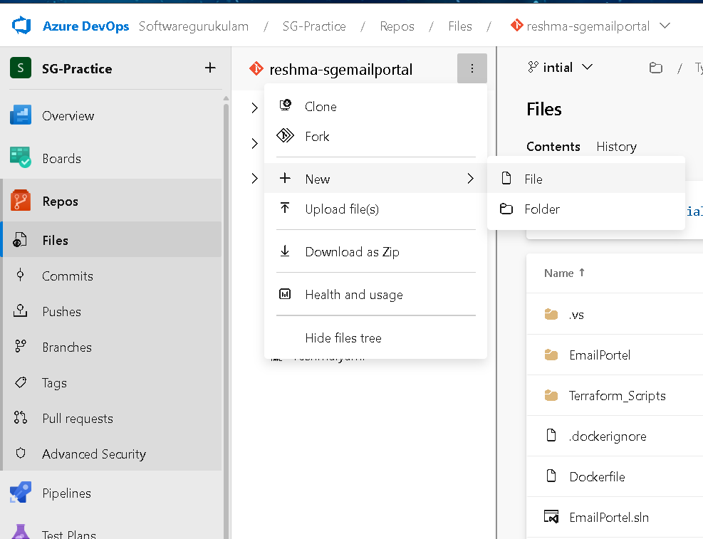

- Here I created a reshma.yaml file

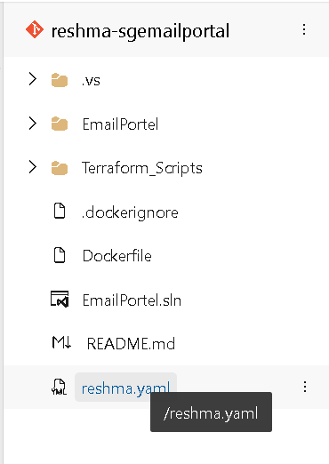

Step 3: Go to Pipeline:
- New pipeline->Azure repos git(yaml).
- select your repository where we created the .yaml file
- Select existing azure pipeline YAML

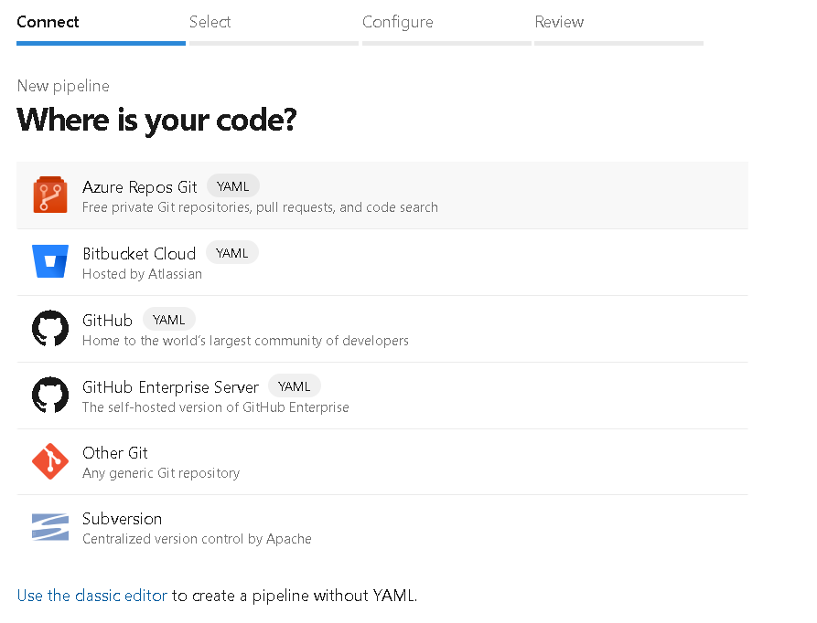

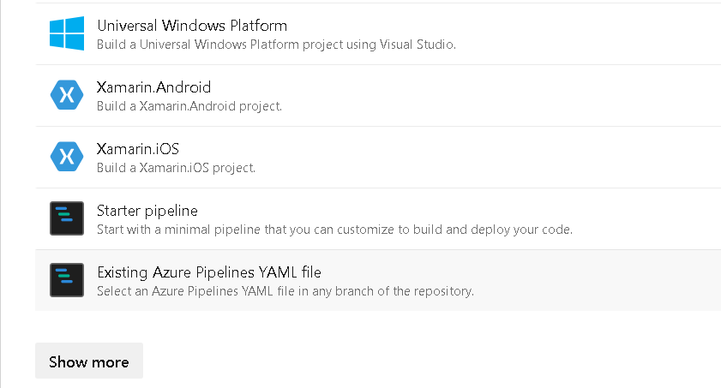

- Select your branch and give the path
- Continue

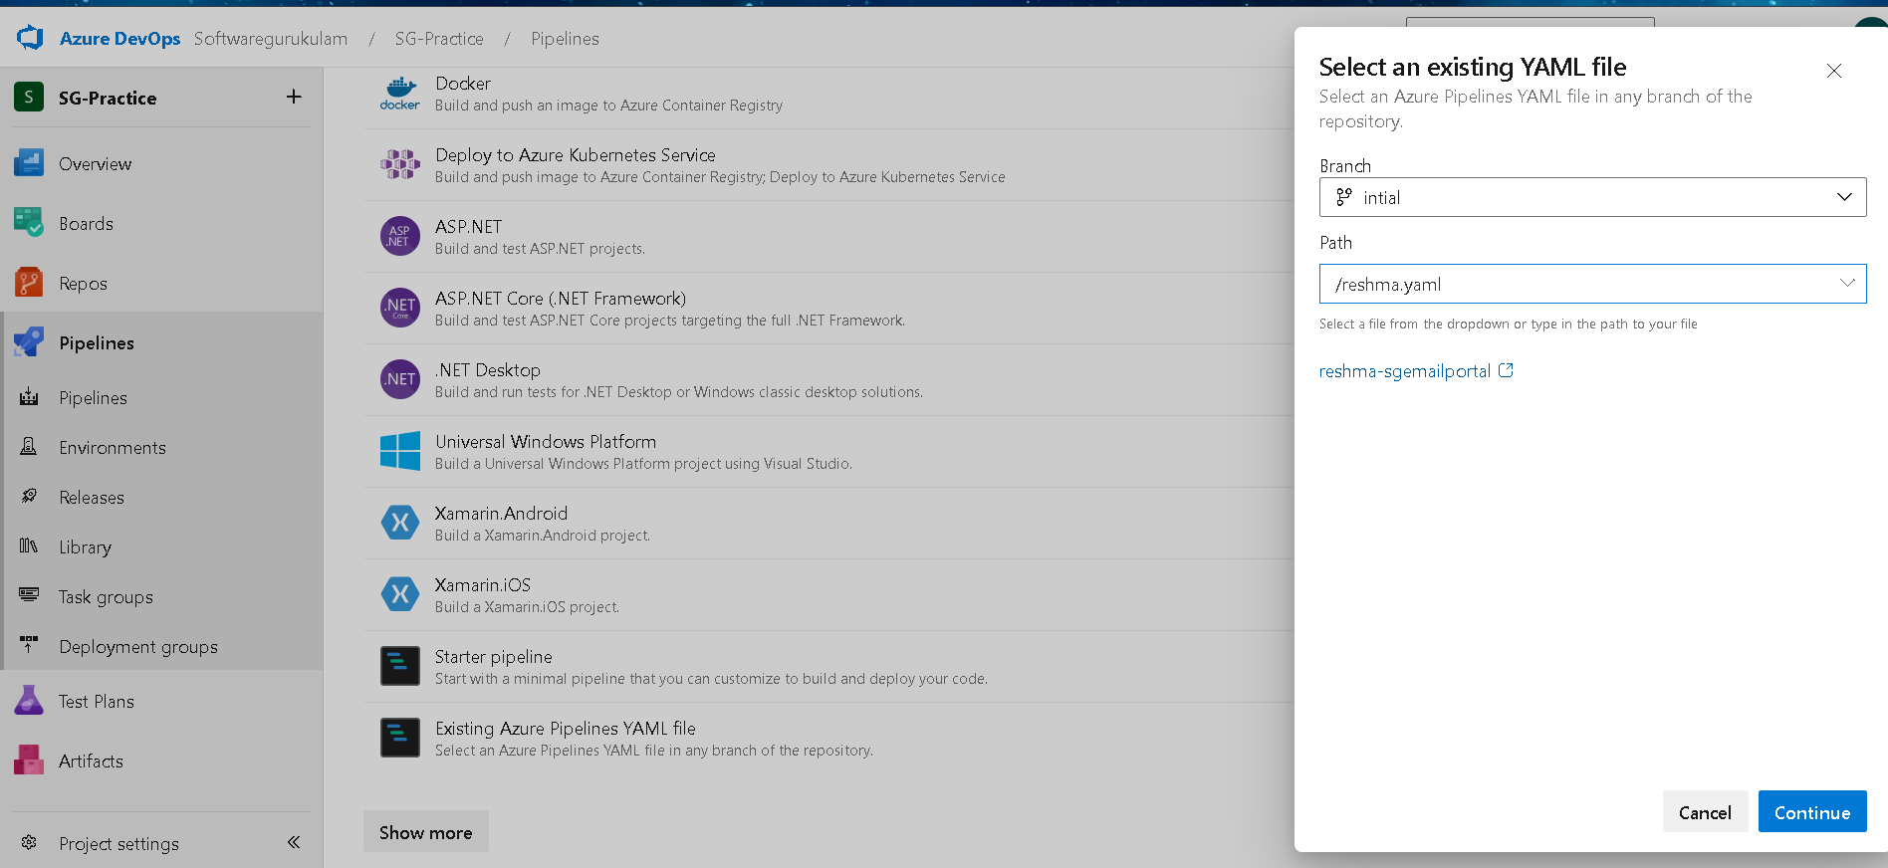

Step 4: Write the code

- The Show assistant is useful to add the .net tasks in the code
      - Nuget tool installer
      - Nuget Restore
      - Ms Build
      - Copy files
      - Publish Build Artifacts

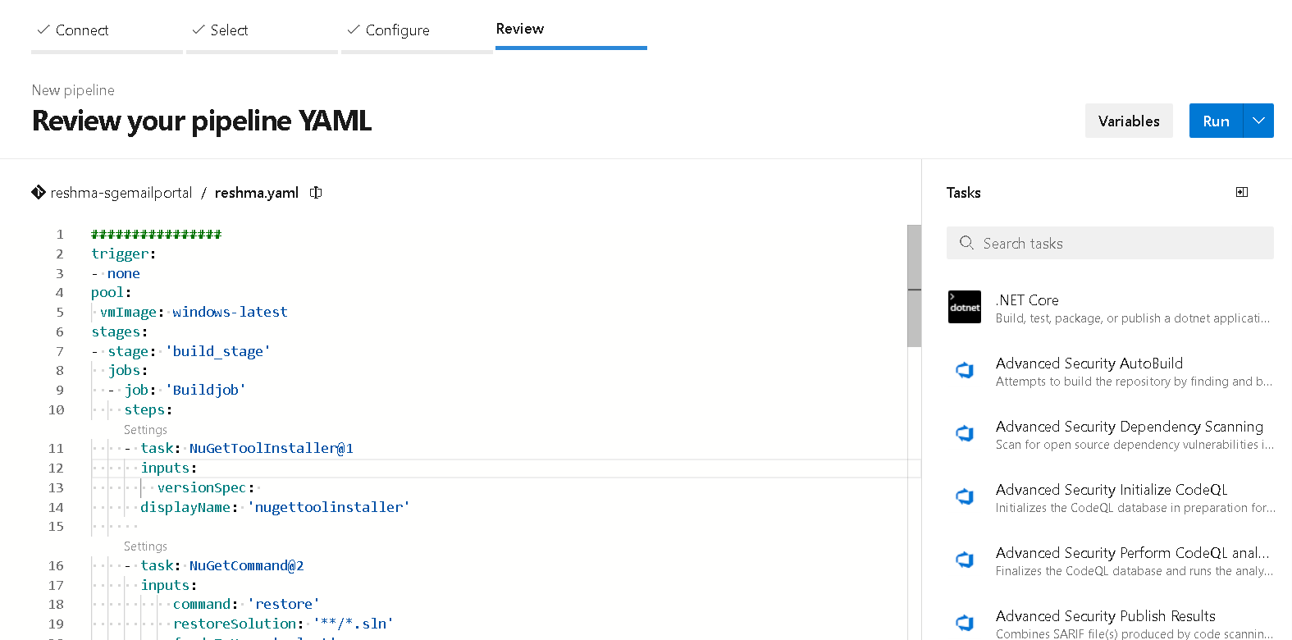

YAML code for the .NET Application

################
trigger:
- none
pool:
vmImage: windows-latest
stages:
- stage: 'build_stage'
jobs:
- job: 'Buildjob'
steps:
- task: NuGetToolInstaller@1
inputs:
versionSpec:
displayName: 'nugettoolinstaller'

- task: NuGetCommand@2
inputs:
command: 'restore'
restoreSolution: '**/*.sln'
feedsToUse: 'select'
displayName: 'restoreindependencies'

- task: MSBuild@1
inputs:
solution: '**/*.sln'
platform: 'Any CPU'
configuration: 'release'
msbuildArguments: '/p:DeployOnBuild=true /p:WebPublishMethod=FileSystem /p:publishUrl="$(build.artifactstagingdirectory)\\WebPublish" /p:DeployDefaultTarget=WebPublish'

- task: CopyFiles@2
inputs:
SourceFolder: '$(agent.builddirectory)'
Contents: '**/*.tf'
TargetFolder: '$(build.artifactstagingdirectory)'

- task: PublishBuildArtifacts@1
inputs:
PathtoPublish: '$(Build.ArtifactStagingDirectory)'
ArtifactName: 'drop'
publishLocation: 'Container'
- stage: 'dummy_stage'
jobs:
- job: job1
steps:

- task: Bash@3
inputs:
targetType: 'inline'
script: |
# Write your commands here

echo 'Hello world'
echo 'releases'

Step 5: Save and Run the pipeline

- Pipeline successfully Build

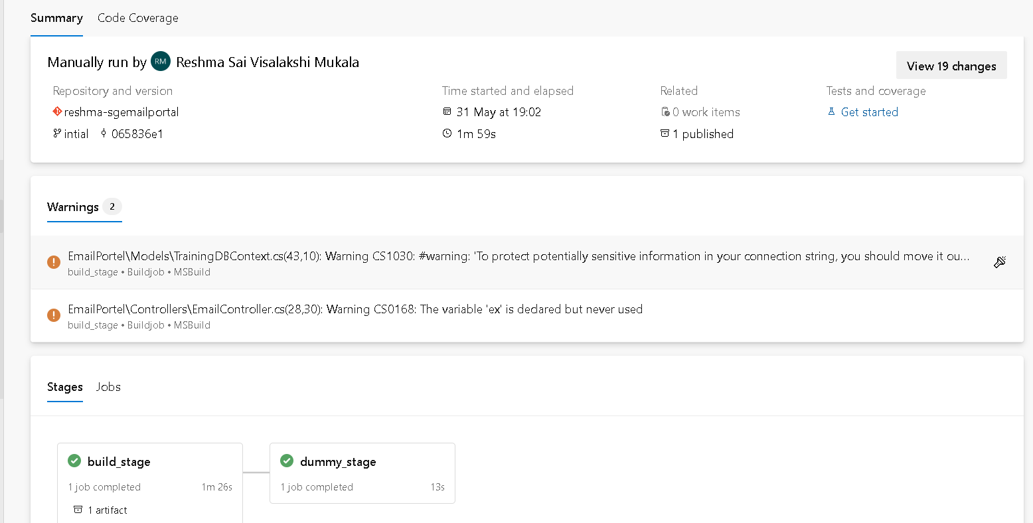

- In the above pipeline, the build stage installs NuGet, restores dependencies, builds the .NET solution, and publishes artifacts. The dummy stage simulates a deployment using basic echo commands.

- Go to published there we can see our artifacts

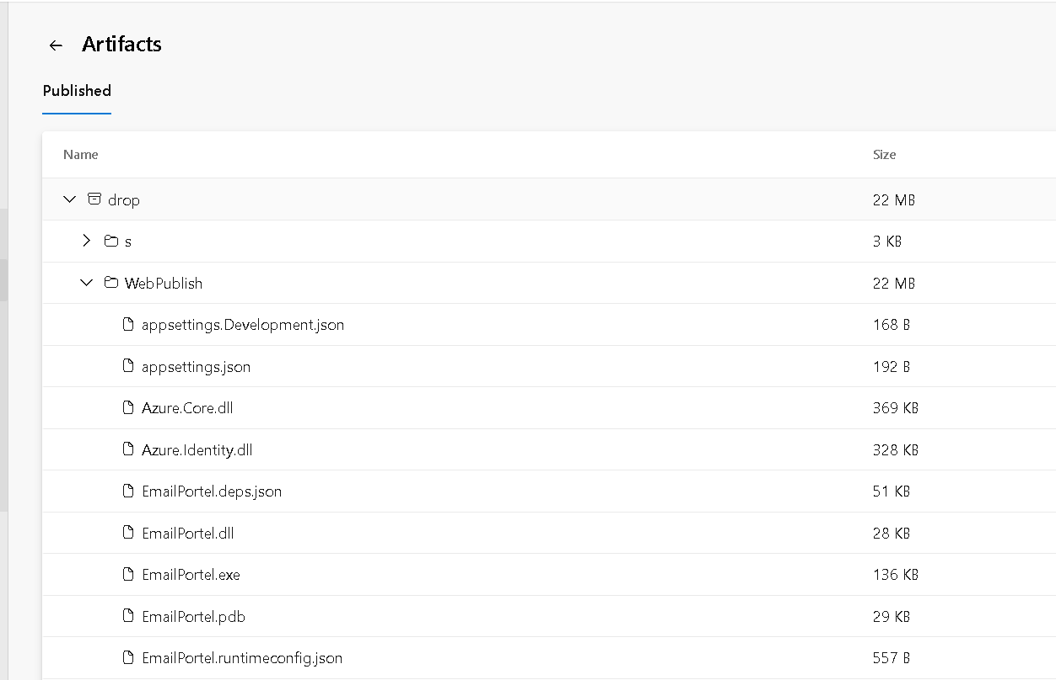

Conclusion:
This YAML-based pipeline automates the build and prepares for deployment of a .NET application using Azure DevOps. You can later replace the dummy stage with real deployment steps for full CI/CD.

